1. Go to Tcode SMARTFORM
2. Select Form radio button and Enter the name with Z/Y and click on create

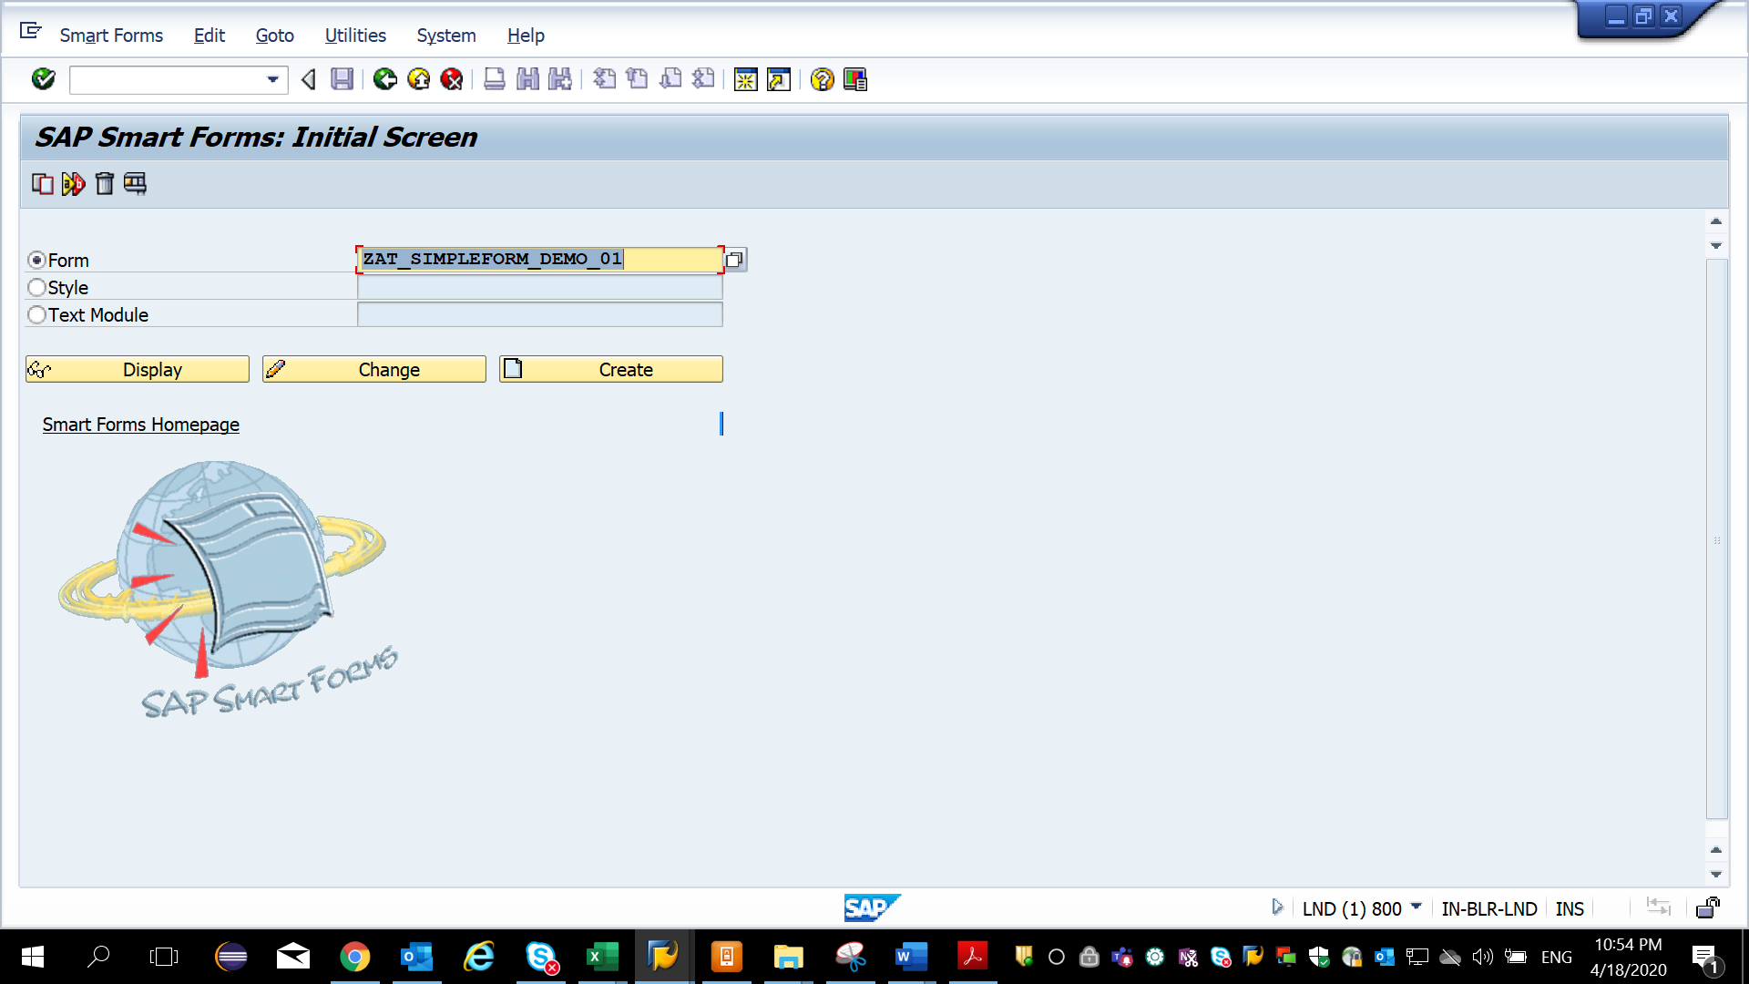

1. Expand **Pages and Windows** folder

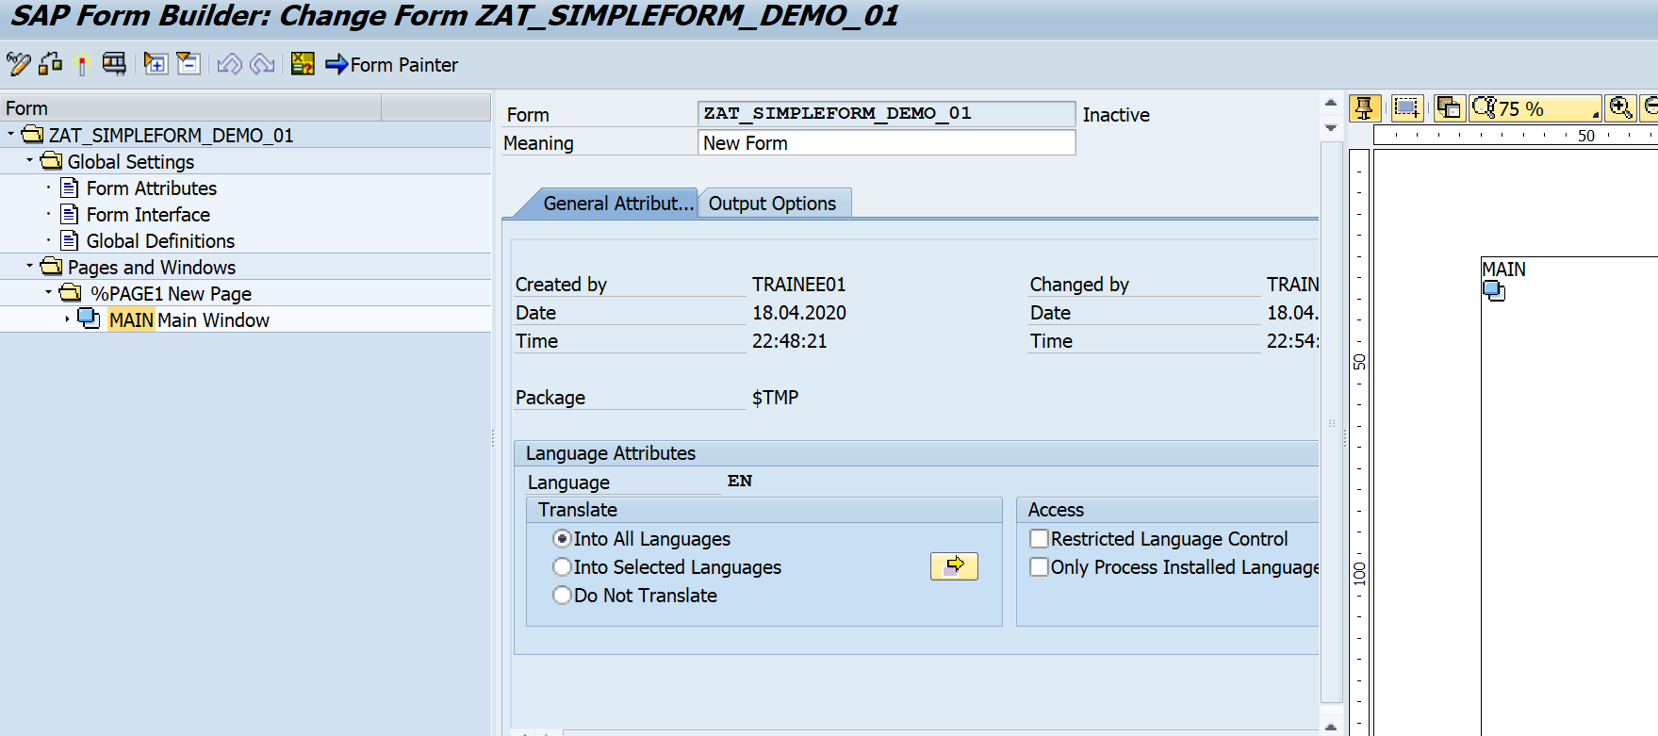

1. Right click on Main Window and create Text.

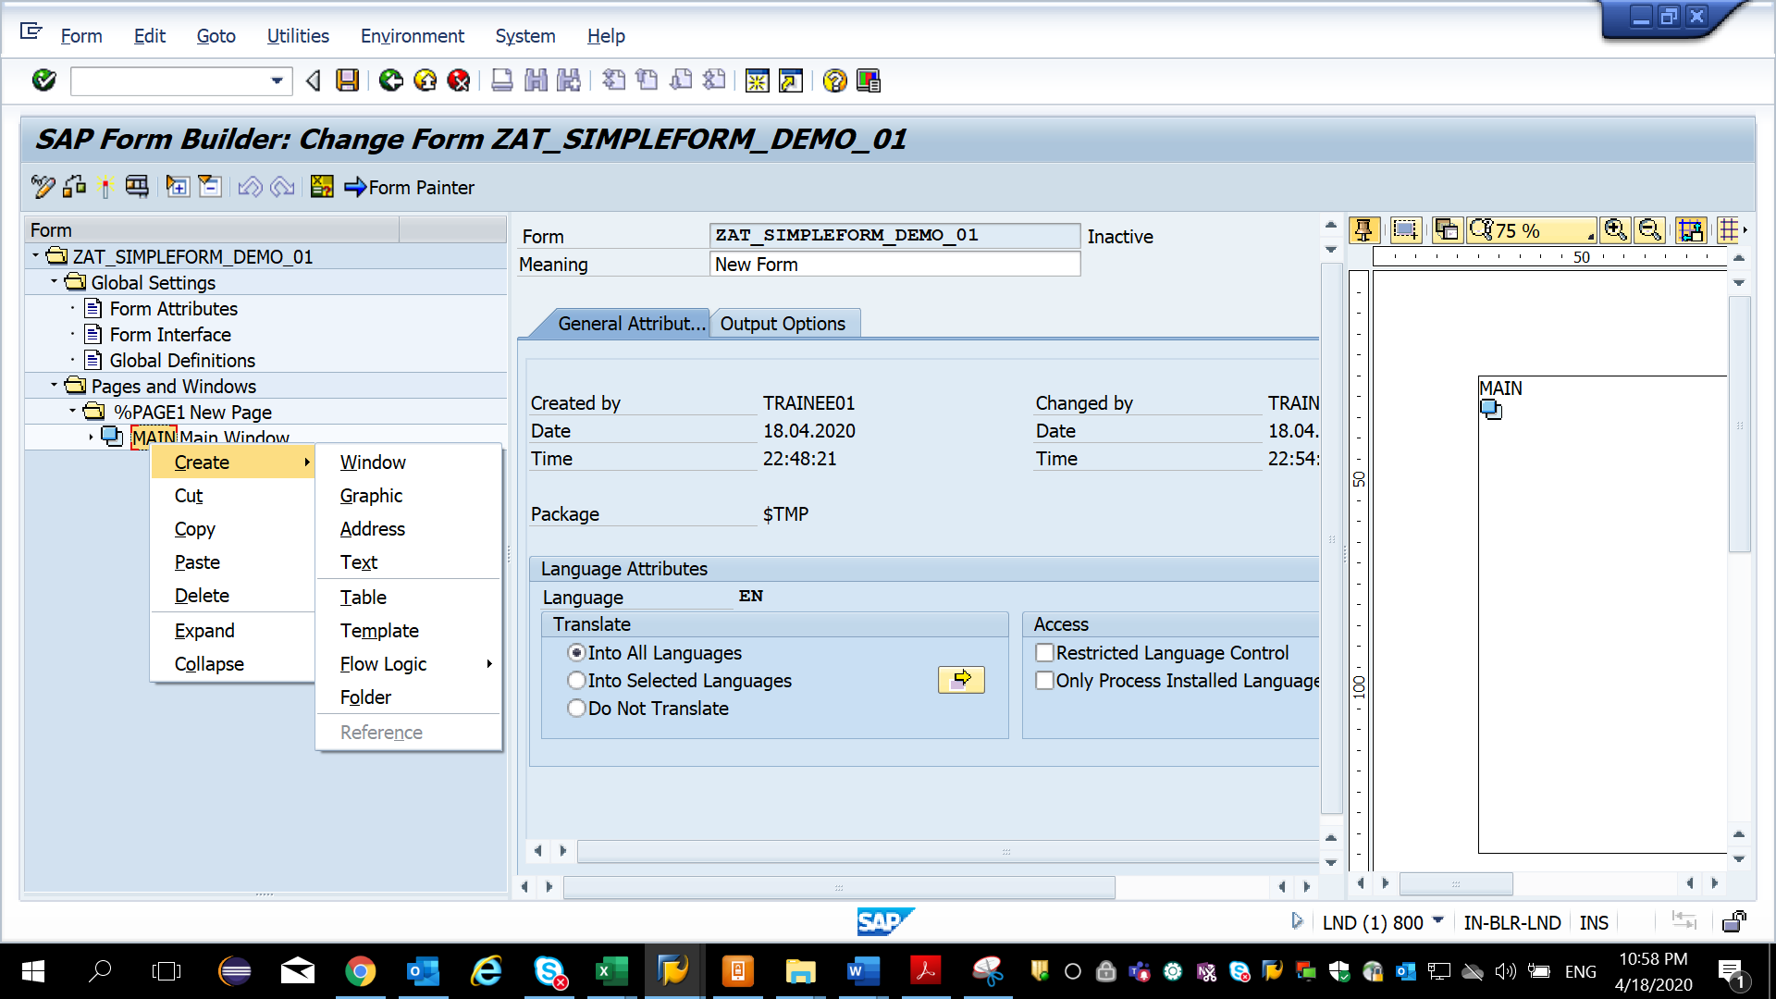

5) Click on General Attributes and write the text

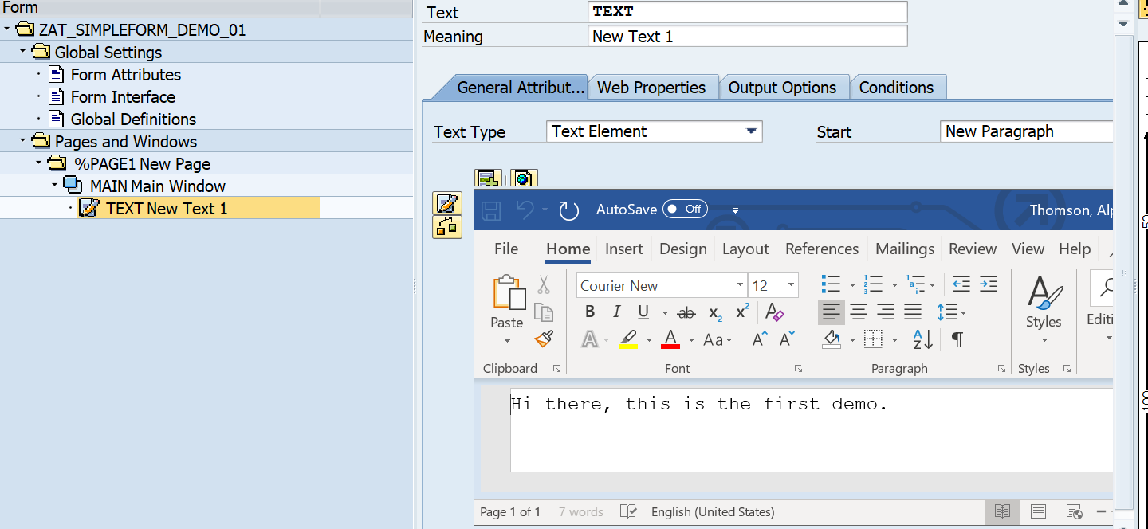

6) save and activate and execute - Function module name can be seen next

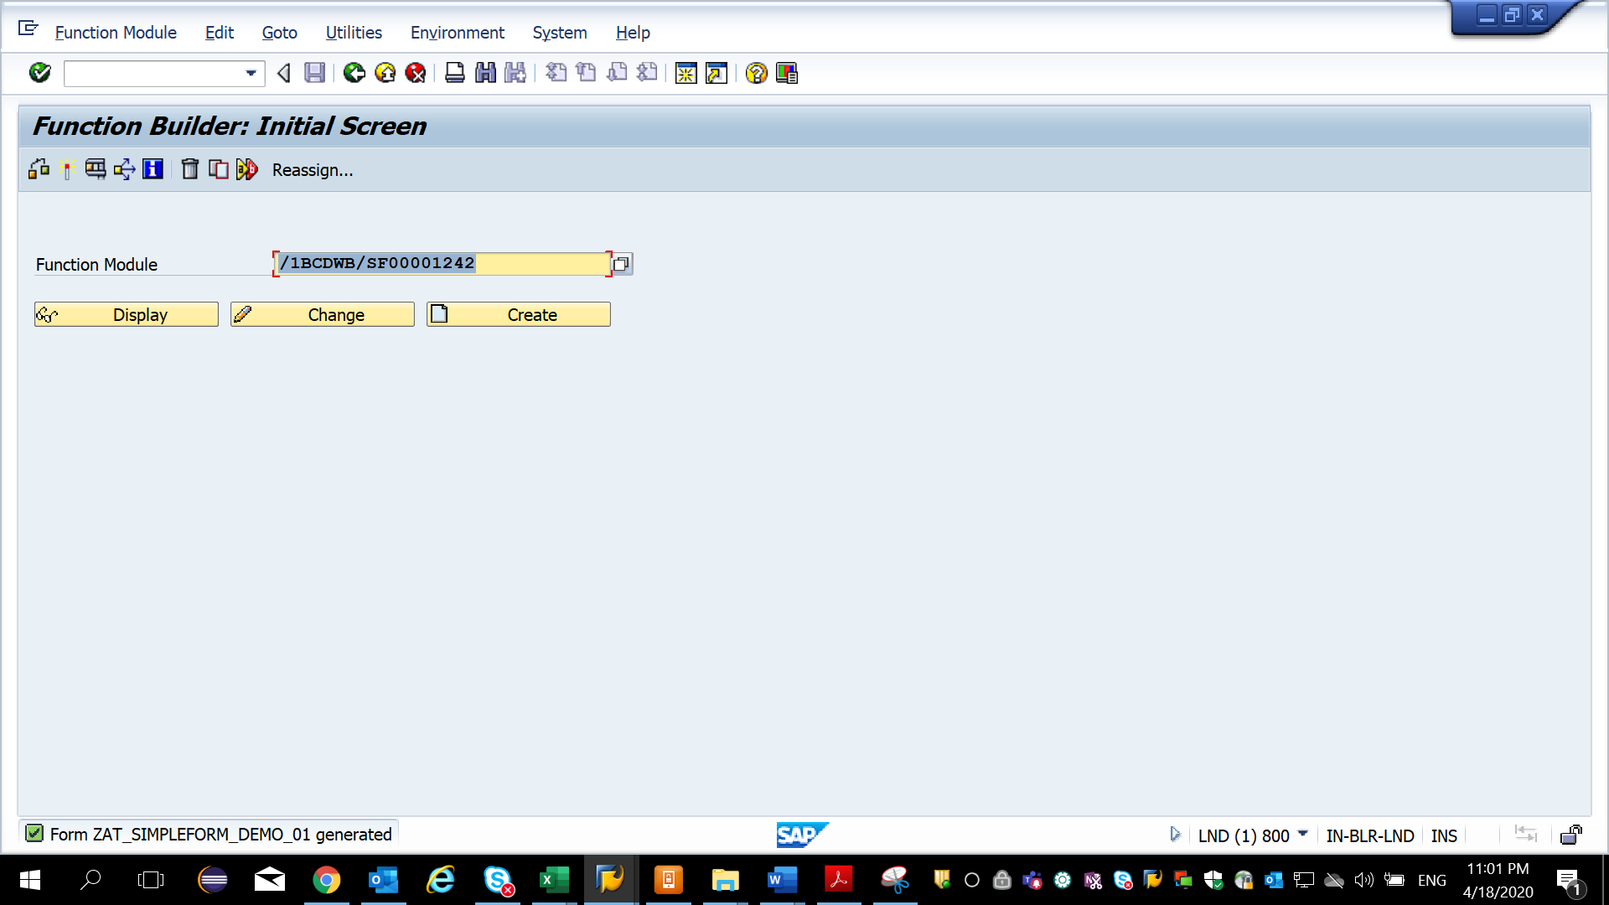

7) execute the function module.

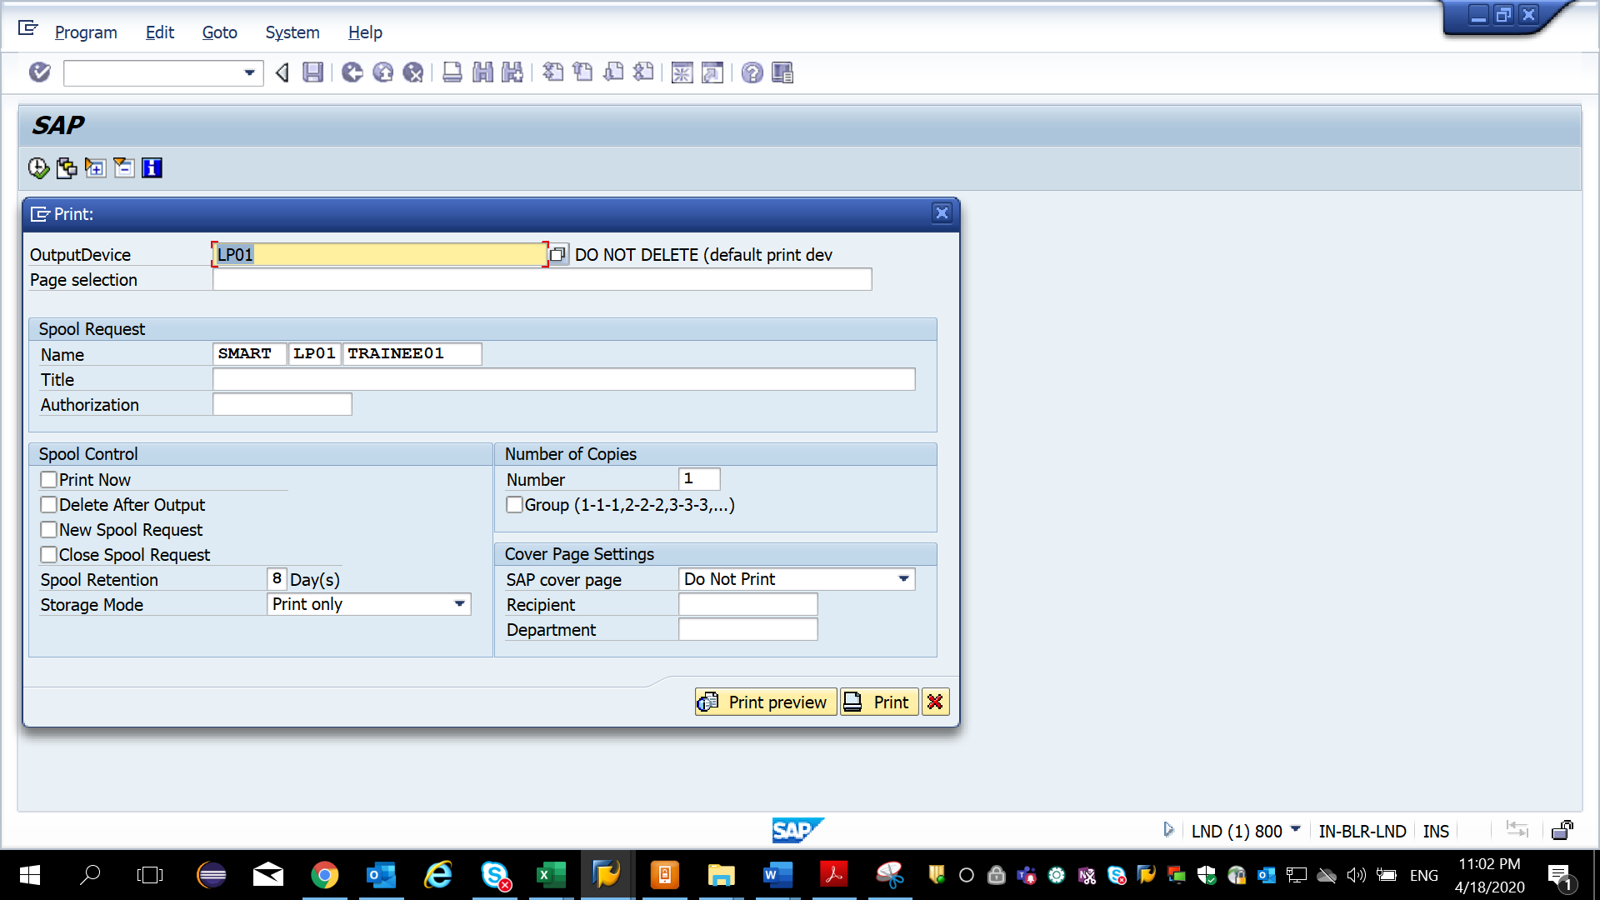

8) Click Print Preview and can see the output

